PATIENT REGISTRATION

TODAY’S DATE:_____________
Single
Widow Name Date of Birth Married
Spouse’s name Date of Birth Divorced
If a child, parent’s name
Address City State Zip
Home Phone Cell Phone________________________Work Phone__________________

Whom may we thank for referring you? ___________________________________________________

Employer
Business address
Present position
In case of emergency, who should be notified: Phone
Person responsible for this account
Social Security # Driver’s license # _____

Email Address:____________________________________________________________________________________

If you would like to pay with Credit Card:
Credit Card Information MasterCard Visa Amex Discover
Name on card
Card # ________________ Exp Date _____/_____ CVV___________

Dental Insurance Information:
Insurance Carrier __Subscriber Name_____________________________DOB_______________ ID or SSN # _______ _____________Group #_____________________________________
Insurance company address
City State Zip

Release of Information:
I authorize the release of information including the diagnosis, records; examination rendered to me, claims and payment information. This information may be released to:

Spouse:______________________________________________________
Child(ren):____________________________________________________
Parent(s):_____________________________________________________
Other:________________________________________________________

Information is not to be released to anyone.

This Release of Information will remain in effect until terminated by me in writing.
Signed: ________________________________________________ Date:____________________

Additional Information:
May we call your work? Yes No
May we call your home? Yes No
May we call your cell? Yes No
May we leave a message on your answering machine to:
Remind you of appointments? Yes No
Ask you to call the office back? Yes No

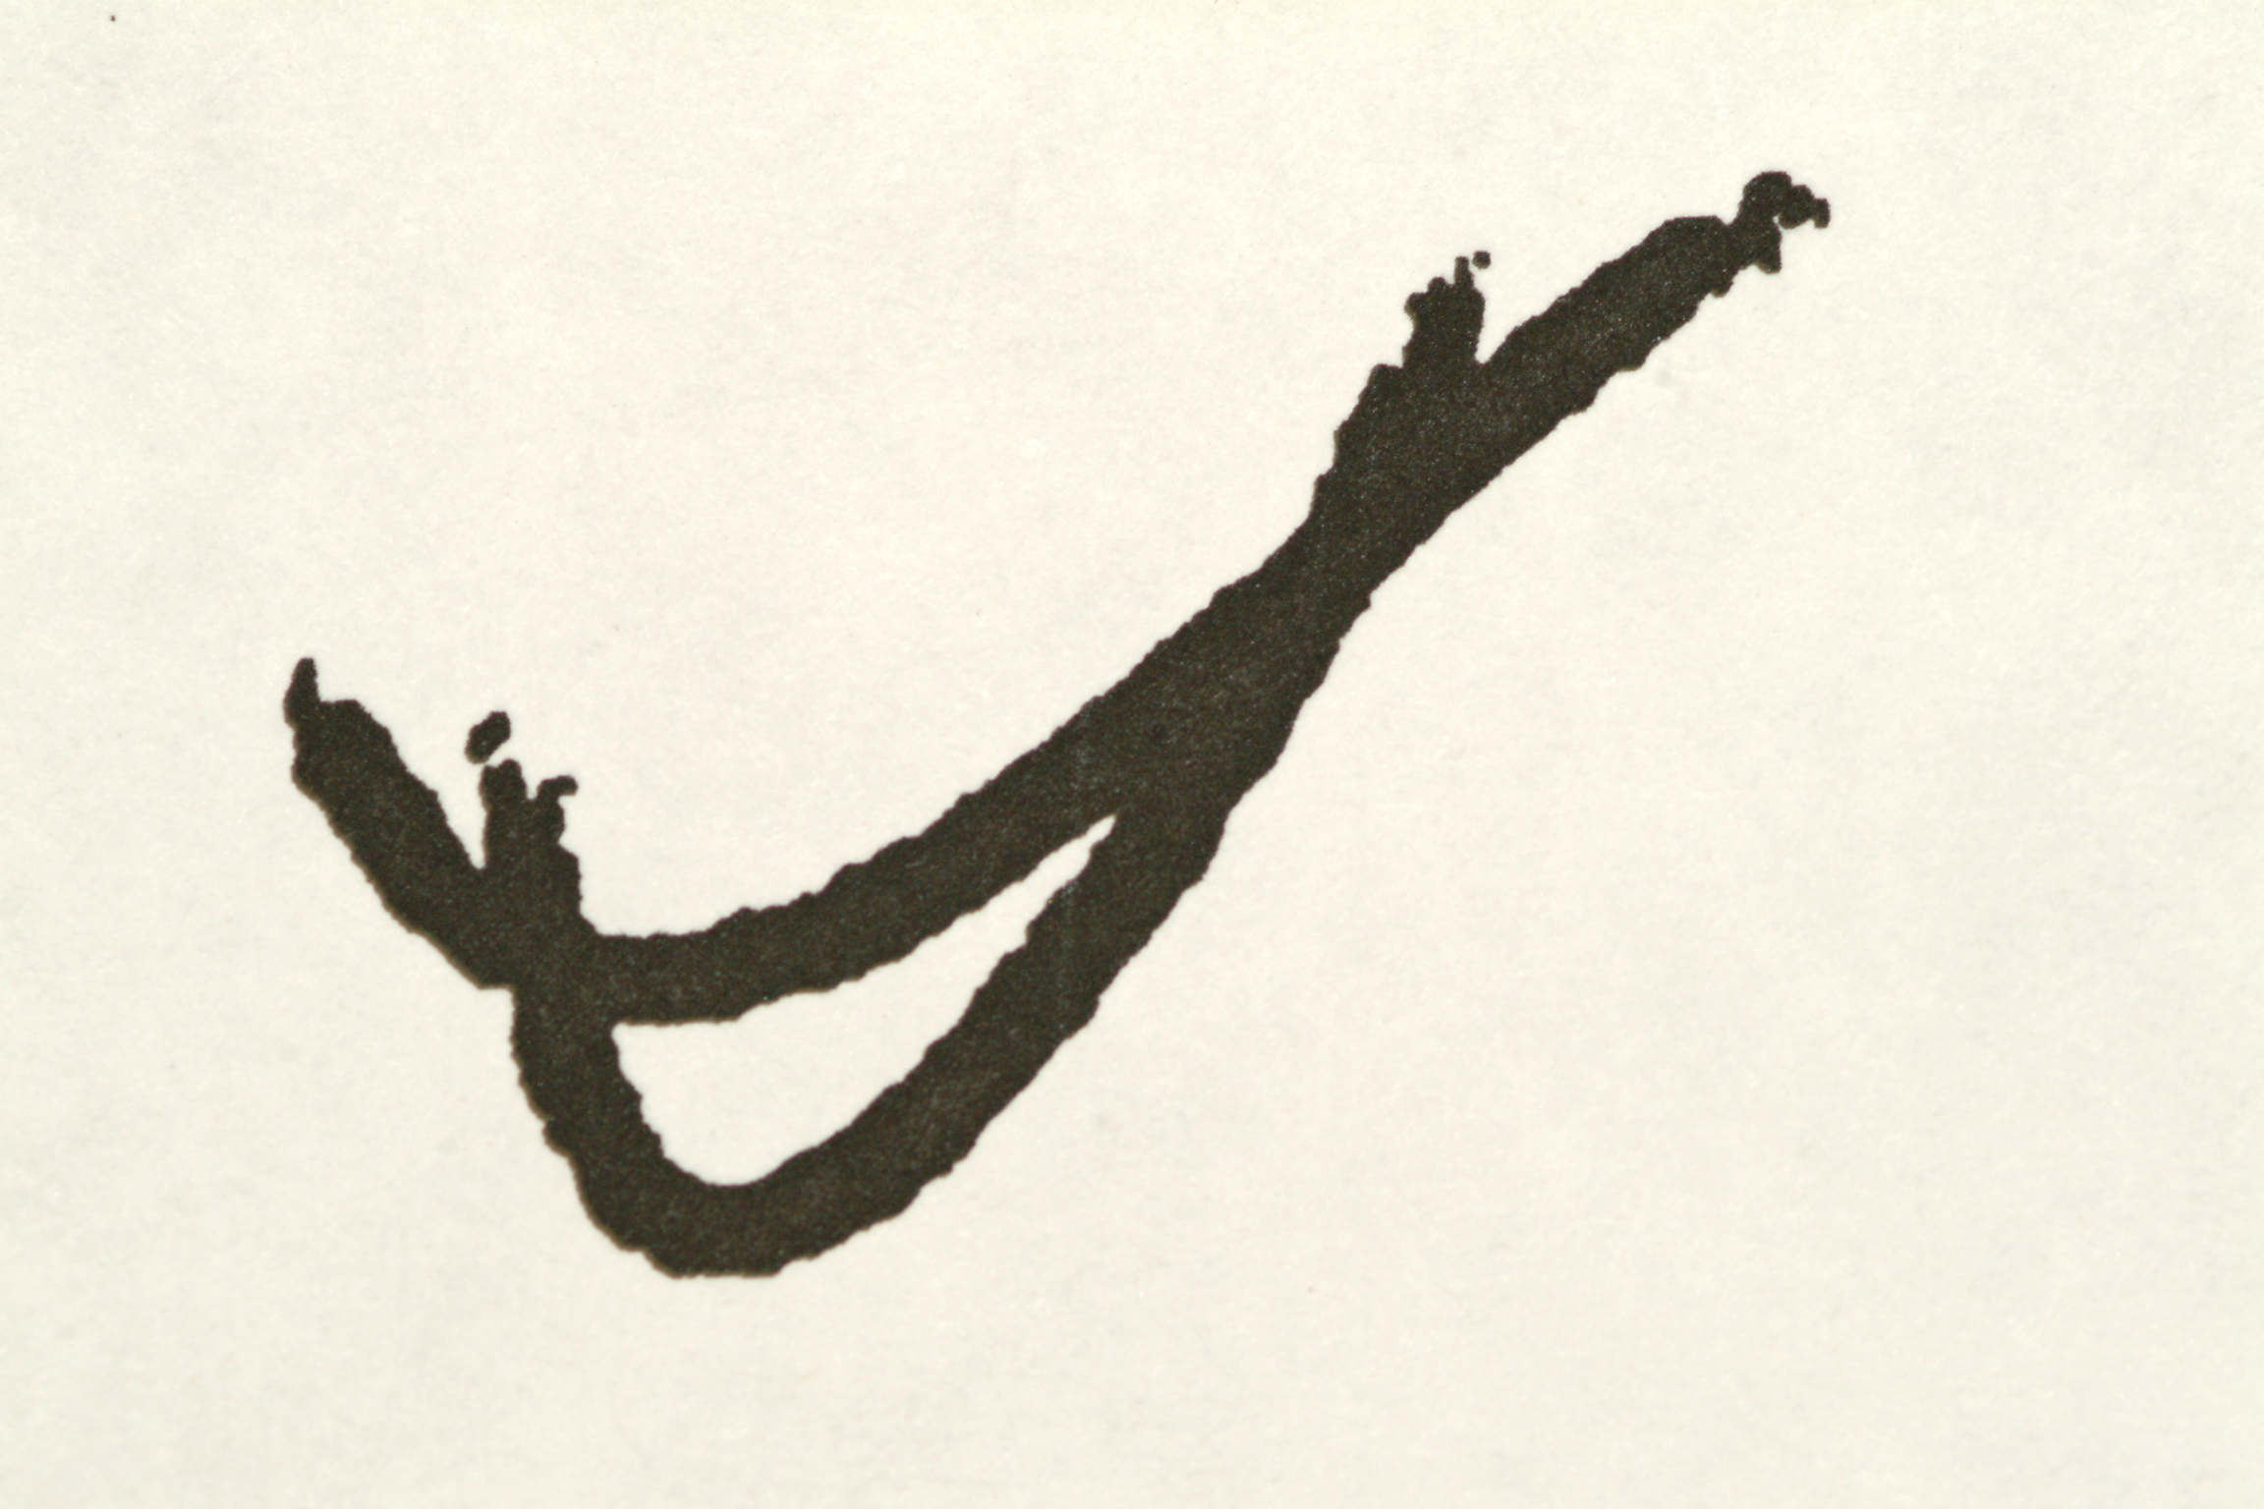Advanced Dental Concepts, 2193 West Chester Pike, Broomall, PA 19008
(610)353-6161 www.drwhitesmile.com

Consent for Services

As a condition of your treatment by this office, financial arrangements must be made in advance. The practice depends upon reimbursement from the patients for the costs incurred in their care and financial responsibility on the part of each patient must be determined before treatment.

All emergency dental services, or any dental services performed without previous financial arrangements, must be paid for at the time services are performed.

Patients who carry dental insurance understand that all dental services furnished are charged directly to the patient and that he or she is personally responsible for payment of all dental services. This office will help prepare the patients insurance forms or assist in making collections from insurance companies and will credit any such collections to the patient's account. However, this dental office cannot render services on the assumption that our charges will be paid by an insurance company.

A service charge of 1½% per month (18% per annum) on the unpaid balance will be charged on all accounts exceeding 60 days, unless previously written financial arrangements are satisfied. I will also be responsible for any and all fees associated with collecting any unpaid balance.

I understand that the fee estimate listed for this dental care can only be extended for a period of six months from the date of the patient examination.

In consideration for the professional services rendered to me, or at my request, by the Doctor, I agree to pay therefore the reasonable value of said services to said Doctor, or his assignee, at the time said services are rendered, or within five (5) days of billing if credit shall be extended. I further agree that the reasonable value of said services shall be as billed unless objected to, by me, in writing, within the time for payment thereof. I further agree that a waiver of any breach of any time or condition hereunder shall not constitute a waiver of any further term or condition and I further agree to pay all costs and reasonable attorney fees if suit be instituted hereunder.

I grant my permission to you or your assignee, to telephone me at home or at my work to discuss matters related to this form.

I understand that should I fail to attend an appointment; I will be subject to a fee of up to $150 per scheduled hour missed, which will be applied to my balance. When our office schedules your appointment, we are reserving a dedicated chair and time slot just for you. Our policy is that if you must reschedule your appointment that you must provide us with at least 24 hours’ notice. This courtesy makes it possible to give your reserved time slot to another patient in need. When your appointment is made, a time is reserved, your materials are ordered, and we make special arrangements to be ready for your visit. Except for emergency treatment for another patient, you can expect us to be prompt. We, of course, would appreciate the same courtesy from you. *Repeated cancellations or missed appointments can result in loss of future appointment privileges and possible dismissal from the practice.

I have read the above conditions of treatment, appointment policy and payment and agree to their content.

____________________________________________________ Date: _____________ Relationship to Patient:
Signature of patient, parent or guardian

____________________________________________________ Date: _____________ Relationship to Patient:
Signature of guarantor of payment/responsible party

